In-Class Assignment - 3

Kartik Velede

8672807

Branding - Style Guides – INFO8920

Joseph Olubobokun

August – 19 – 2020

August – 19– 2020

1. Before applying the CSS code styling to the page

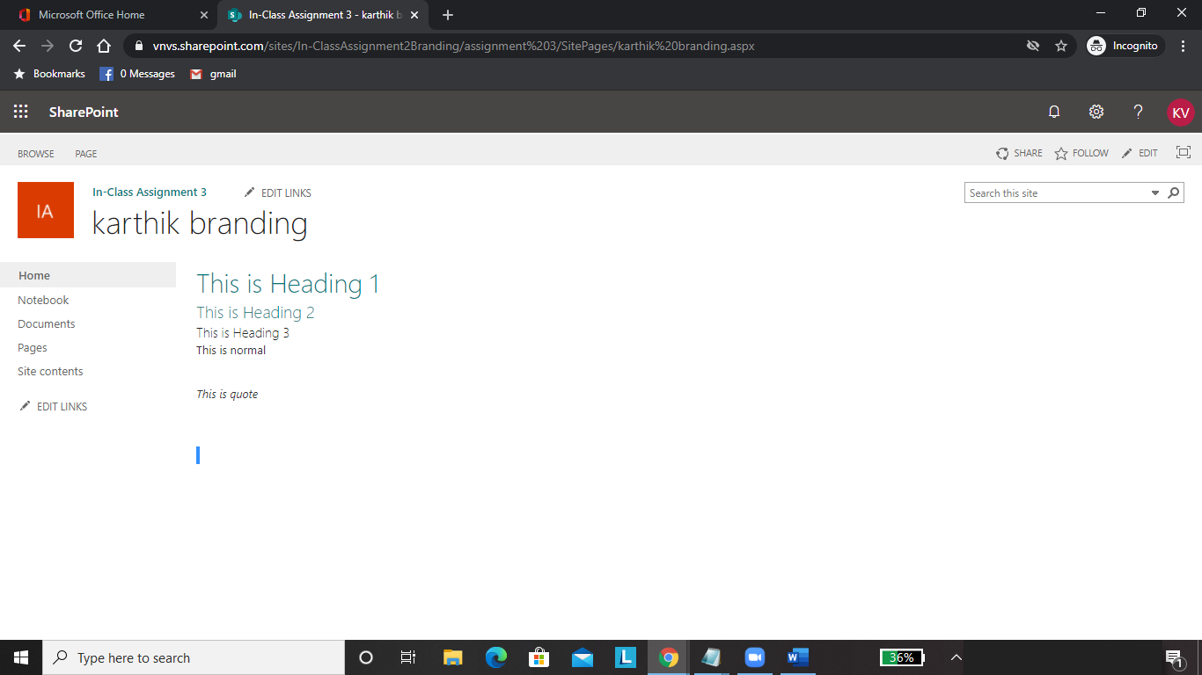

1. After applying the CSS code styling to page

